OBSERVATION RECORD
USEFUL WEBSITES FOR STUDENTS
Ex. No.: 1 Date: 20/10/26

Aim
To design and develop a multi-page static website using semantic HTML5 elements and CSS to display useful websites for students, their benefits, learning resources, and a feedback form.

Description
- The website contains four linked pages: Home, Websites, Learning Resources, and Feedback.
- Semantic HTML5 elements such as header, nav, main, section, article, and footer organize the content.
- The Websites page presents Google, YouTube, Wikipedia, W3Schools, and GitHub in a table with external links.
- The Learning Resources page uses images, descriptions, and an ordered list of study habits.
- The Feedback page contains a name field, selection lists, a comments box, and a submit button.
- CSS is used for colours, spacing, borders, alignment, and consistent navigation.
- The feedback form demonstrates HTML form controls only; it does not store or send data to a server.

Procedure
- Create a folder named useful_websites_multpage_project.
- Create four HTML files: index.html, websites.html, resources.html, and feedback.html.
- Add a navigation menu to each page to connect all four webpages.
- Use semantic HTML5 elements to organize headings, content, tables, images, and forms.
- Apply CSS styles for colours, spacing, alignment, and borders.
- Save all four files in the same folder and open index.html in a web browser.
- Click every navigation link and test the external website links and feedback controls.

Coding
Create the following four files in the same folder. Each file contains a complete HTML document with internal CSS.

index.html
<!DOCTYPE html>
<html lang="en">
<head>
<meta charset="UTF-8">
<meta name="viewport" content="width=device-width, initial-scale=1.0">
<title>Student Web Guide - Home</title>
<style>
body { margin: 0; font-family: Arial, sans-serif; background: #f2f8e9; color: #222; }
header, footer { background: #214d2a; color: white; text-align: center; padding: 22px; }
nav { background: #36723e; text-align: center; padding: 12px; }
nav a { color: white; text-decoration: none; margin: 12px; font-weight: bold; }
main { max-width: 900px; margin: 25px auto; padding: 20px; }
.hero { background: white; padding: 24px; border-radius: 12px; text-align: center; }
.hero img { width: 100%; max-width: 520px; border-radius: 10px; }
.button { display: inline-block; background: #36723e; color: white; padding: 10px 16px; border-radius: 6px; text-decoration: none; }
</style>
</head>
<body>
<header>
<h1>Useful Websites for Students</h1>
<p>A simple guide to websites that support learning and coding</p>
</header>
<nav>
<a href="index.html">Home</a>
<a href="websites.html">Websites</a>
<a href="resources.html">Learning Resources</a>
<a href="feedback.html">Feedback</a>
</nav>
<main>
<section class="hero">
<h2>Welcome, Students!</h2>
<p>Explore helpful websites for searching, learning, practising code, and sharing projects.</p>
<img src="https://placehold.co/800x360/214d2a/ffffff?text=Student+Web+Guide" alt="Student Web Guide banner">
<p><a class="button" href="websites.html">Explore Websites</a></p>
</section>
<section>
<h2>How this website helps</h2>
<ul>
<li>Find information for assignments and projects.</li>
<li>Watch educational videos and tutorials.</li>
<li>Practise HTML and CSS basics.</li>
<li>Organise and share coding projects.</li>
</ul>
</section>
</main>
<footer><p>Student Web Guide | HTML5 Practical Project</p></footer>
</body>
</html>

websites.html
<!DOCTYPE html>
<html lang="en">
<head>
<meta charset="UTF-8">
<meta name="viewport" content="width=device-width, initial-scale=1.0">
<title>Student Web Guide - Websites</title>
<style>
body { margin: 0; font-family: Arial, sans-serif; background: #f2f8e9; color: #222; }
header, footer { background: #214d2a; color: white; text-align: center; padding: 20px; }
nav { background: #36723e; text-align: center; padding: 12px; }
nav a { color: white; text-decoration: none; margin: 12px; font-weight: bold; }
main { max-width: 950px; margin: 25px auto; padding: 15px; }
table { width: 100%; border-collapse: collapse; background: white; }
th, td { border: 1px solid #456b45; padding: 12px; text-align: left; }
th { background: #cce8b8; }
.name { background: #ddf3c9; font-weight: bold; }
a { color: #205b2a; }
</style>
</head>
<body>
<header><h1>Useful Websites</h1><p>Five websites students can use for learning</p></header>
<nav>
<a href="index.html">Home</a>
<a href="websites.html">Websites</a>
<a href="resources.html">Learning Resources</a>
<a href="feedback.html">Feedback</a>
</nav>
<main>
<h2>Website List</h2>
<table>
<tr><th>S.No</th><th>Website</th><th>Purpose</th><th>Link</th></tr>
<tr><td>1</td><td class="name">Google</td><td>Search for information and learning materials.</td><td><a href="https://www.google.com/">Visit</a></td></tr>
<tr><td>2</td><td class="name">YouTube</td><td>Watch educational videos and tutorials.</td><td><a href="https://www.youtube.com/">Visit</a></td></tr>
<tr><td>3</td><td class="name">Wikipedia</td><td>Read introductory information about many topics.</td><td><a href="https://www.wikipedia.org/">Visit</a></td></tr>
<tr><td>4</td><td class="name">W3Schools</td><td>Learn and practise HTML, CSS, and other web basics.</td><td><a href="https://www.w3schools.com/">Visit</a></td></tr>
<tr><td>5</td><td class="name">GitHub</td><td>Store and share coding projects.</td><td><a href="https://github.com/">Visit</a></td></tr>
</table>
<p>Use reliable sources and check important information against more than one source.</p>
</main>
<footer><p>Student Web Guide | HTML5 Practical Project</p></footer>
</body>
</html>

resources.html
<!DOCTYPE html>
<html lang="en">
<head>
<meta charset="UTF-8">
<meta name="viewport" content="width=device-width, initial-scale=1.0">
<title>Student Web Guide - Learning Resources</title>
<style>
body { margin: 0; font-family: Arial, sans-serif; background: #f2f8e9; color: #222; }
header, footer { background: #214d2a; color: white; text-align: center; padding: 20px; }
nav { background: #36723e; text-align: center; padding: 12px; }
nav a { color: white; text-decoration: none; margin: 12px; font-weight: bold; }
main { max-width: 950px; margin: 25px auto; padding: 15px; }
.cards { display: flex; flex-wrap: wrap; gap: 18px; justify-content: center; }
article { background: white; border: 1px solid #c8dfbd; border-radius: 10px; padding: 15px; width: 240px; }
article img { width: 100%; border-radius: 8px; }
article a { color: #205b2a; }
</style>
</head>
<body>
<header><h1>Learning Resources</h1><p>Ways to learn and practise new skills</p></header>
<nav>
<a href="index.html">Home</a>
<a href="websites.html">Websites</a>
<a href="resources.html">Learning Resources</a>
<a href="feedback.html">Feedback</a>
</nav>
<main>
<section>
<h2>How each website helps students</h2>
<div class="cards">
<article>
<img src="https://placehold.co/400x220/4285f4/ffffff?text=Google" alt="Google search illustration">
<h3>Google</h3>
<p>Helps students search for explanations, articles, and useful resources.</p>
<a href="https://www.google.com/">Open Google</a>
</article>
<article>
<img src="https://placehold.co/400x220/e62117/ffffff?text=YouTube" alt="YouTube learning illustration">
<h3>YouTube</h3>
<p>Offers video lessons, demonstrations, and recorded tutorials.</p>
<a href="https://www.youtube.com/">Open YouTube</a>
</article>
<article>
<img src="https://placehold.co/400x220/287a3e/ffffff?text=W3Schools" alt="W3Schools coding illustration">
<h3>W3Schools</h3>
<p>Provides beginner examples for HTML, CSS, and web programming.</p>
<a href="https://www.w3schools.com/">Open W3Schools</a>
</article>
</div>
<h2>Good study habits</h2>
<ol>
<li>Read the question carefully before searching.</li>
<li>Compare information from trustworthy sources.</li>
<li>Practise code by typing and testing it yourself.</li>
<li>Keep project files organised.</li>
</ol>
</section>
</main>
<footer><p>Student Web Guide | HTML5 Practical Project</p></footer>
</body>
</html>

feedback.html
<!DOCTYPE html>
<html lang="en">
<head>
<meta charset="UTF-8">
<meta name="viewport" content="width=device-width, initial-scale=1.0">
<title>Student Web Guide - Feedback</title>
<style>
body { margin: 0; font-family: Arial, sans-serif; background: #f2f8e9; color: #222; }
header, footer { background: #214d2a; color: white; text-align: center; padding: 20px; }
nav { background: #36723e; text-align: center; padding: 12px; }
nav a { color: white; text-decoration: none; margin: 12px; font-weight: bold; }
main { max-width: 700px; margin: 25px auto; padding: 20px; background: white; border-radius: 10px; }
label { display: block; margin-top: 14px; font-weight: bold; }
input, select, textarea { width: 100%; padding: 10px; margin-top: 6px; box-sizing: border-box; }
button { margin-top: 18px; background: #36723e; color: white; border: 0; padding: 11px 18px; border-radius: 6px; }
</style>
</head>
<body>
<header><h1>Student Feedback</h1><p>Share your thoughts about this website</p></header>
<nav>
<a href="index.html">Home</a>
<a href="websites.html">Websites</a>
<a href="resources.html">Learning Resources</a>
<a href="feedback.html">Feedback</a>
</nav>
<main>
<h2>Feedback Form</h2>
<p>This sample form demonstrates HTML form elements. It does not send data to a server.</p>
<form action="#" method="get">
<label for="studentname">Your name:</label>
<input type="text" id="studentname" name="studentname" placeholder="Enter your name" required>
<label for="purpose">Main purpose:</label>
<select id="purpose" name="purpose">
<option>Assignments</option>
<option>Learning coding</option>
<option>Watching tutorials</option>
<option>Sharing projects</option>
</select>
<label for="rating">Website rating:</label>
<select id="rating" name="rating">
<option>5 - Excellent</option>
<option>4 - Very Good</option>
<option>3 - Good</option>
<option>2 - Fair</option>
<option>1 - Needs Improvement</option>
</select>
<label for="comments">Comments:</label>
<textarea id="comments" name="comments" rows="4" placeholder="Write your comments"></textarea>
<button type="submit">Submit Feedback</button>
</form>
</main>
<footer><p>Student Web Guide | HTML5 Practical Project</p></footer>
</body>
</html>

Output Screenshots
The following screenshots show the actual output of the four webpages in a browser.

Output 1 — Home page (index.html)
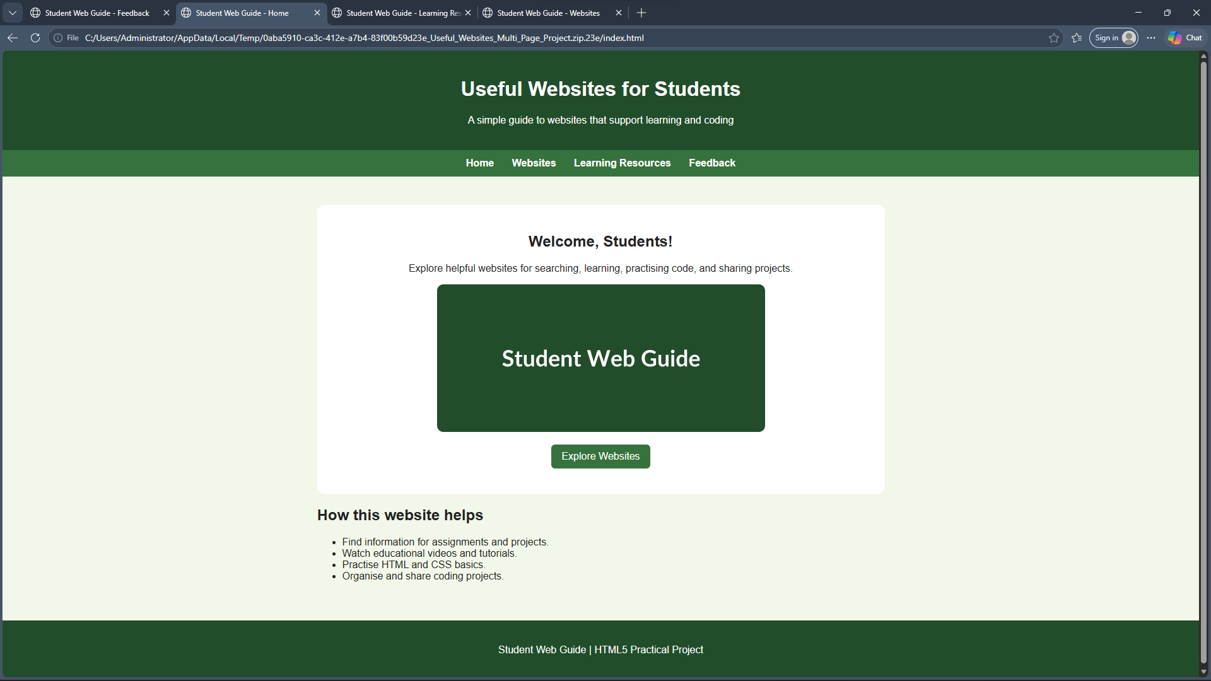

Output 2 — Websites page (websites.html)
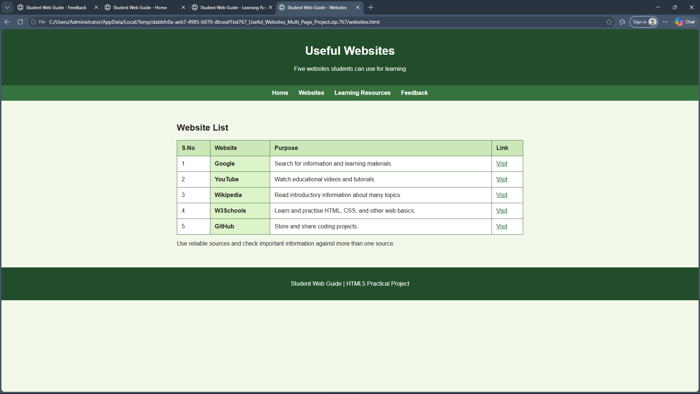

Output 3 — Learning Resources page (resources.html)
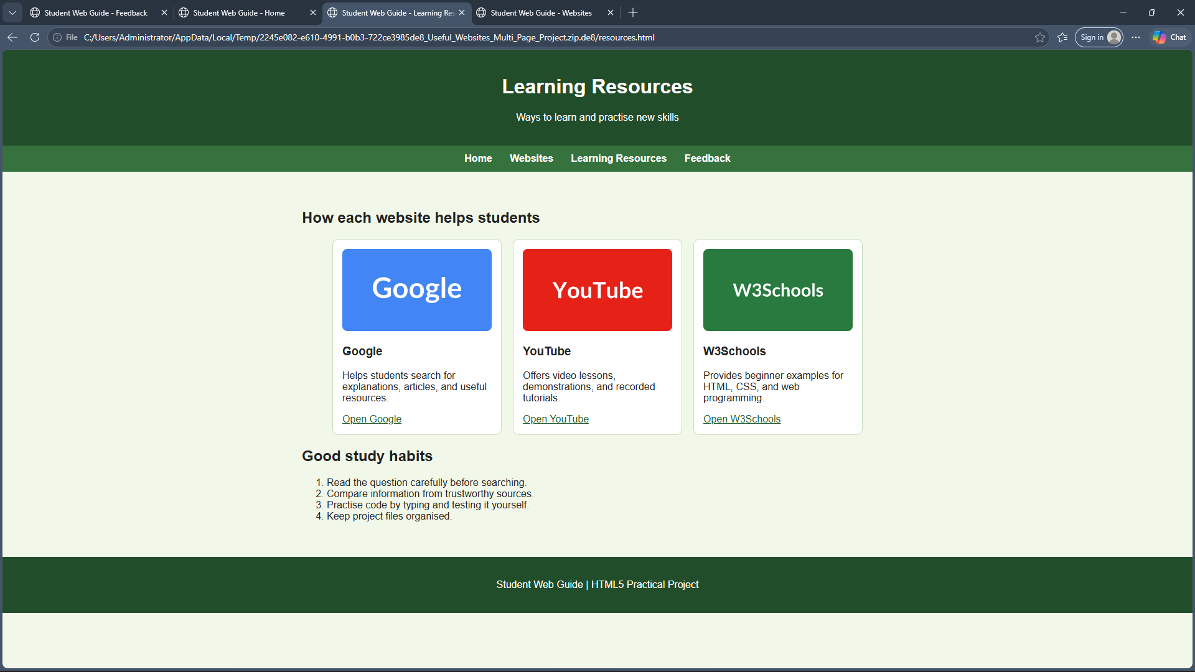

Output 4 — Feedback page (feedback.html)
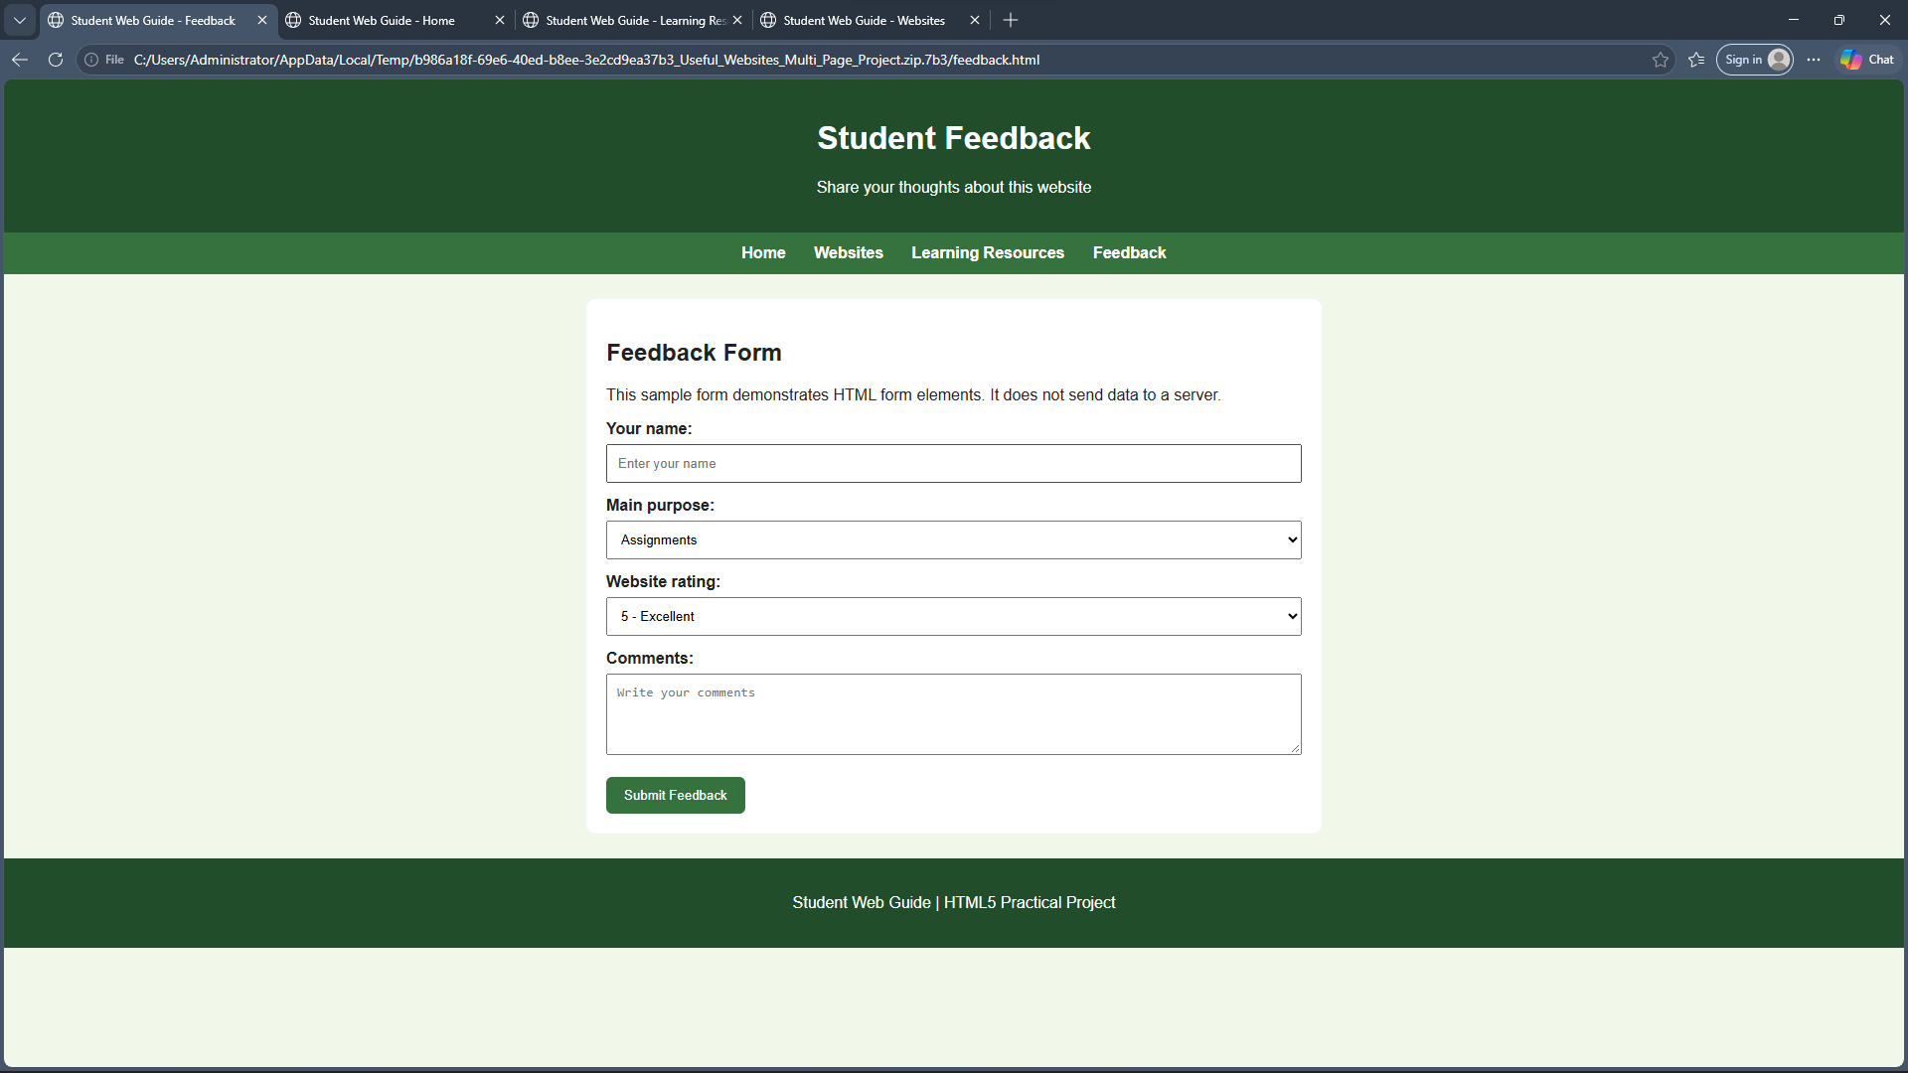

Result
Thus, a multi-page static website for useful student websites was developed using HTML5 and CSS. It includes four interconnected webpages, semantic structure, a table, external hyperlinks, images, lists, and a feedback form.

